# Intro

Software Engineering:

* Creative process, few right/wrong answers, with more requirement and designs, choices must be evaluated and justified.
* Software: set of instruction data or programs, used to operate computer, and do task
* Engineering: applying systematic and technological knowledge, scientific, and well-defined processes to produce good quality product
* SE is people focussed activity.
* Goal: improvement in the business

Requirements

* Software capability: needed by user solve problem and achieve objective, must met, or possessed by system to do a contract, standard, specification.
* Requirement analysis: process of studying user needs include system, hardware, and software requirement.

Design

Process of define architecture, system, element, interface, result in requirement analysis.

Methodologies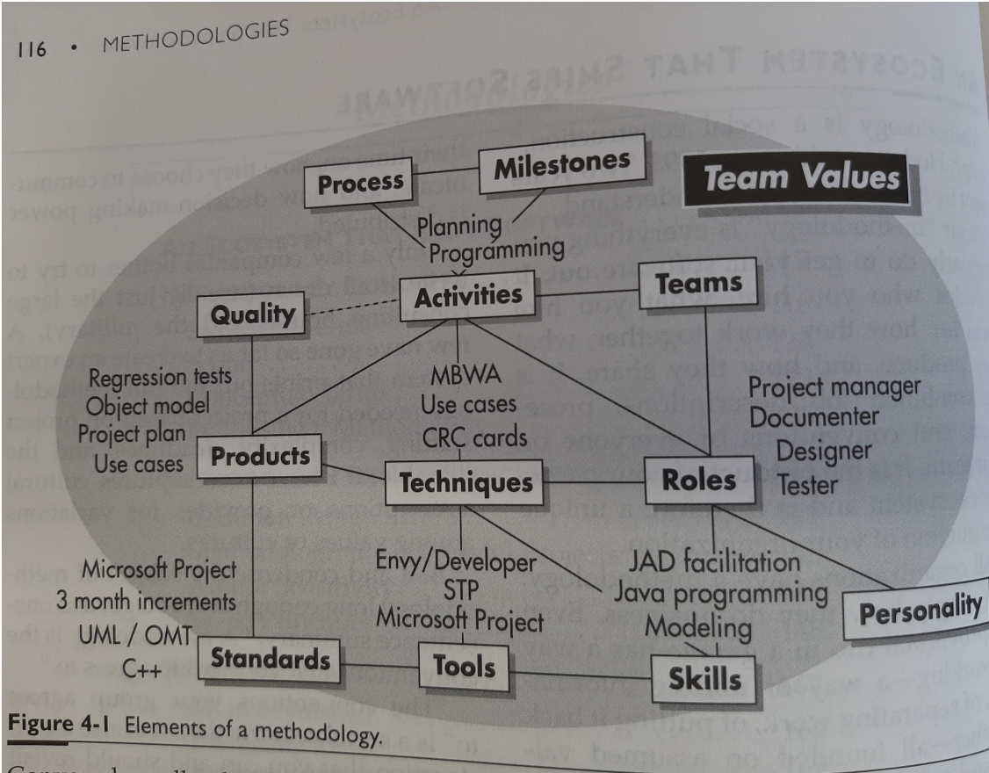

* System of practices, tech, procedures and rules used by who work in discipline
* Kind of guideline, tells developers to do their work
* Methodologies specify processes, work products, and consider people and tools in development. They represent how organizations conduct their business and entail consensus on conventions. In essence, they provide structured frameworks for software development, emphasizing systematic procedures and agreed-upon conventions.

Processes

* Interrelated activities and task to transform input work product to output work product.
  + Activities: how people spend days: planning programming testing meeting
  + Process: How activates fit, with pre and post conditions for activities. E.g. design review after 2 days of designs.

Why bother with requirement and design:

* Requirement deal with uncertainty; engineers need thing concrete to work toward:” is solution fit purpose.”
* Completed program shows requirement all met and it is effective.

# User Stories

Software Requirements: people design software; stakeholder; user stories; Volere snow cards.

And requirement drifting due to the time.

* People: often get ignore but SE need working effectively with people and solving tech problem
* Stakeholder: person/group/organization affect/affected by decision, activity, outcome of project, some stakeholder may oppose each other/project, but they all interest in the outcome
  + E.g.: end users, end user organizations, supporters, developers, producers, trainers, maintainers, disposers, acquirers, supplier organizations and regulatory bodies, interested parties, decision-maker
* Users: who interact with system product and service
  + operators, recipients of the results of operating the system or software; a bank customer who visits a branch, receives a paper statement, or carries out telephone banking using a call centre.
  + Customers: those who receives product, can be internal or external to the organization. Customers are a subset of stakeholders.
    - consumer, client, end-user, retailer
* Actor: human users, external systems, or other software who outside the system interact with system
  + for the online shopping system, you would see stick figures representing "Customer" and "Administrator" outside the system boundary, connected to use cases such as "Browse Products," "Add to Cart," "Manage Products,

User Stories (Won’t replace requirement, both reduce uncertainty)

Purpose: shows how to deliver/provide value back to the customer and other stakeholders

Benefit:

* Stories keep the focus on the user.
  + Task list let team focus on task need to check off and solving problems for user.
* Stories enable collaboration.
  + With goals, team works together for how best to serve user and meet goal.
* Stories drive creative solutions.
  + Encourage team think critically and creatively for best solution.
* Stories create momentum.
  + With passing story, team enjoy small challenge and win.

Format

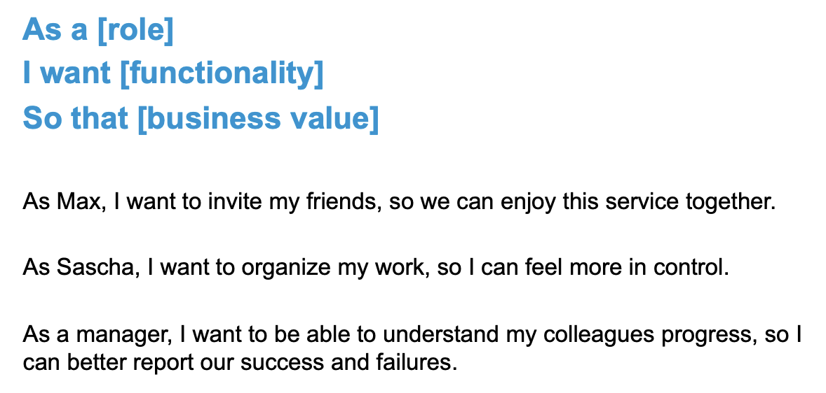

Weakness

Beware: “I want” is almost always followed by a presumed solution: “I want to access my account from my mobile”; etc

Right answer is: Ensure my secure of my account

The So that of this part is not based enough, is not straight to the point.

“So that” is justifying the solution but being able to see your bank balance 24/7 does not solve any real business problem, either for the customer or the bank.

Business stories

How to write

* User stories are about need, describing raw user need.
* Something user need to do in their job.
* Even never build the software, the need still exists.
* In agile approach, tester review US to make sure they are ‘reasonable/testable’, tester represent real user, think, and act like users.

Quality Attributes of User Stories

* Easy for user and everyone to read.
* Developer has a lot of detail, but user stories must be short and clean and express complete thought.
* Each US independent and self-contained of other

Snow card(volere.org)

tool for capturing requirements, including user stories.

Temple

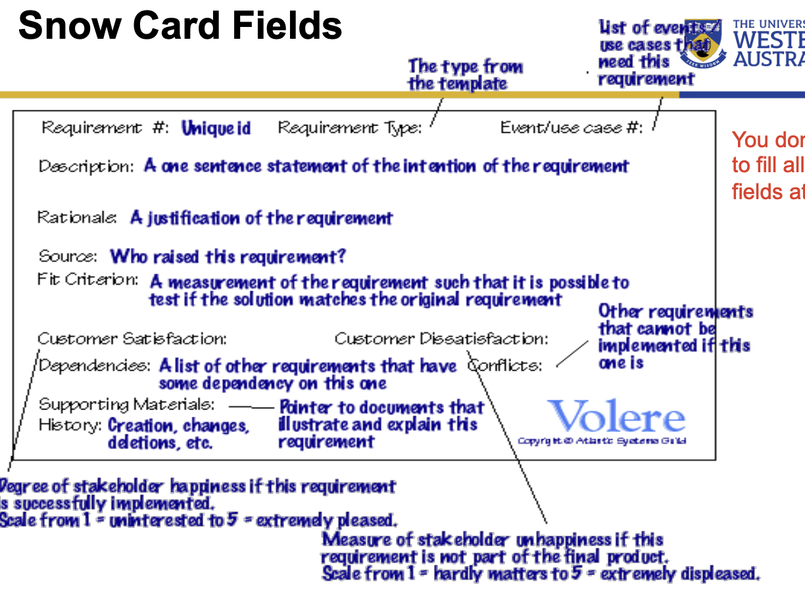

Warning – don’t get confused: UML use case diagram and use case

Example of other format:

ProductPlan

Epic User Story

Index Card

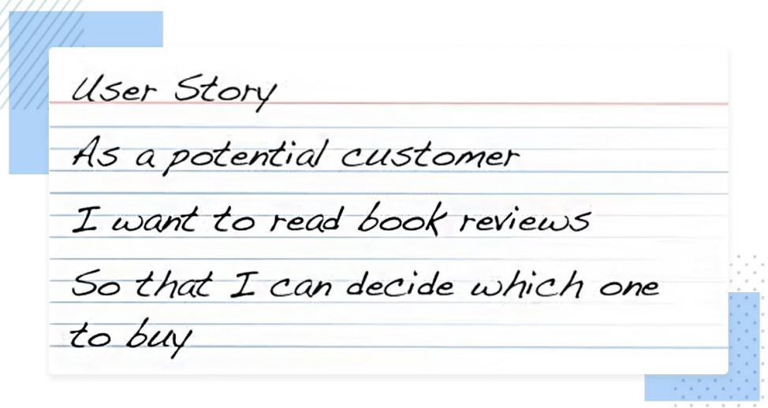

Powerslides

## Workshop

## Scenario

A small start-up company is looking to develop a mobile application that helps users track their daily exercise and eating habits. The app should allow users to set personalized fitness goals, track their progress, and receive reminders and tips to stay motivated.

As a requirement engineering team, your task is to gather and analyse the stakeholders' requirements and develop a comprehensive software requirements specification document.

The stakeholders include the company's founders, the target audience (health-conscious individuals), and potential investors.

To gather the requirements, you conduct interviews with the stakeholders and observe their daily routines. You also conduct surveys to collect user feedback and preferences. Based on the gathered information, you identify the following high-level requirements:

* The app should be user-friendly and visually appealing.
* The app should have a personalized dashboard that displays daily fitness goals, progress, and tips.
* The app should allow users to input their daily meals and track their calorie intake
* The app should integrate with popular fitness wearables such as Fitbit and Apple Watch
* The app should send push notifications to remind users to complete their daily fitness routine.

## Tasks

1.

Who are the stakeholders related to the scenario?

* Company CEO interest with the profit of app by attracting more user with better experience of app and achieve success in his business.
* Investor interest with their investment of this new start-up company, if the app works better and provide more subscription to the company, they can get more profit from their investment.
* Target audience interest with the better performance of the app, they hope the app provide better experience and performance of their excise, and the efficiency of their diet.

2.

What are the user stories for each stakeholder?

As a